Show me, Tell me
facebook.com/dynamixds
The examiner will ask you one:
- ‘tell me’ question (where you explain how you’d carry out a safety task) at the start of your test, before you Start driving
- ‘show me’ question (where you show how you’d carry out a safety task) while you’re driving
‘Show me’ questions
- When it’s safe to do so, can you show me how you wash and clean the rear windscreen?
- When it’s safe to do so, can you show me how you wash and clean the front windscreen?
- When it’s safe to do so, can you show me how you would switch on your dipped headlights?
- When it’s safe to do so, can you show me how you would set the rear demister?
- When it’s safe to do so, can you show me how you would operate the horn?
- When it’s safe to do so, can you show me how you would demist the front windscreen?
- When it’s safe to do so, can you show me how you would open and close the side window?
‘Tell me’ questions
1. Tell me how you would check that the brakes are working before starting a journey.
- Brakes should not feel spongy or slack.
- Brakes should be tested as you set off.
- Vehicle should not pull to one side.
2. Tell me where you would find the information for the recommended tyre pressures for this car and how tyre pressures should be checked.
- Manufacturer’s guide.
- Use a reliable pressure gauge.
- Check and adjust pressures when tyres are cold.
- Check all 5 tyres (don’t forget spare tyre).
- Remember to refit valve caps.
3. Tell me how you make sure your head restraint is correctly adjusted so it provides the best protection in the event of a crash.
- The head restraint should be adjusted so the middle of the head restraint is in line with your eyes or top of your ears.
- Demonstrate by adjusting the head restraint up and down.
- Note: Some restraints might not be adjustable.
4. Tell me how you’d check the tyres to ensure that they have sufficient tread depth and that their general condition is safe to use on the road.
- No cuts and bulges on the sidewall of the tyre.
- A tyre has 1.6mm of tread depth across the central three-quarters of the tyre, all the way around the tyre.
5. Tell me how you would check that the headlights and tail lights are working on your car. (You don’t need to exit the vehicle. It is a “TELL ME” question)
- Explain you would turn the ignition on.
- Explain how you would turn your lights onto dip beam.
- Explain you would walk round the vehicle and check your front and rear lights are working.
6. Tell me how you would know if there was a problem with your anti-lock braking system.
- The ABS (Anti-locking brakes) light should go out when the engine is started.
- If there is a fault the ABS (Anti-locking brakes system) light on the dash board will come on and stay on.
7. Tell me how you would check the direction indicators are working. You don’t need to exit the vehicle.
- Explain you would turn the ignition on.
- Explain how you would turn your hazard lights on.
- Explain you would walk round the vehicle and check your 6 indicator lights are working.
8. Tell me how you would check the brake lights are working on this car.
- Explain you would turn the ignition on.
- Explain that you would press the brake pedal.
- Explain how you would make use of reflections in windows or doors.
- Or ask someone to go round the back of the car and check the brake lights are working.
9. Tell me how you would check the power-assisted steering is working before starting a journey.
- If the steering becomes heavy, the system may not be working properly.
- Gentle pressure on the steering wheel without the engine running, the steering will be heavy.
- Start the engine.
- Gentle pressure on the steering wheel with the engine running, the steering will be light.
10. Tell me how you would switch on the rear fog light(s) and explain when you’d use it/them. You don’t need to exit the vehicle.
- Explain you would turn the ignition on.
- Explain you would turn your lights onto dip beam.
- Explain you would switch on your rear fog light/s.
- Explain the amber fog light symbol on dash board.
- Explain you would walk round to the back of the vehicle and check your rear fog light/s are working.
- Fog lights are used when visibility is less than 100 meters (bit longer than a football field, 100m running track)
11. Tell me how you switch your headlight from dipped to main beam and explain how you would know the main beam is on.
- Explain you would turn the ignition on.
- Explain you would turn your lights onto dip beam.
- Explain you would push the indicator switch away from you to put main beam on.
- Explain you would see the blue main beam light on the dash board.
12. Open the bonnet and tell me how you would check that the engine has sufficient oil.
- Identify the dipstick/oil level indicator.
- Explain remove dipstick and wipe.
- Replace the dipstick back into the engine.
- Remove the dipstick again.
- Check level is up against the max mark.
13. Open the bonnet and tell me how you would check that the engine has sufficient engine coolant.
- Identify high and low level markings on the coolant tank.
- Explain how to top up to correct level.
- Remove the cap (WHEN COOLANT IS COLD ONLY) fill up with the right mix of coolant and water to the max level.
14. Open the bonnet and tell me how you would check that you have a safe level of hydraulic brake fluid.
- Identify reservoir.
- Identify the max marker.
- Top up with brake fluid to the max marker.

15. Open the bonnet and tell me how you would check that you have enough fluid in your windscreen washer bottle.
- Identify the windscreen washer bottle.
- Explain there is NO max level on the bottle.
- Explain fill to the top of the bottle with the right mix of washer fluid and water.

Under the bonnet
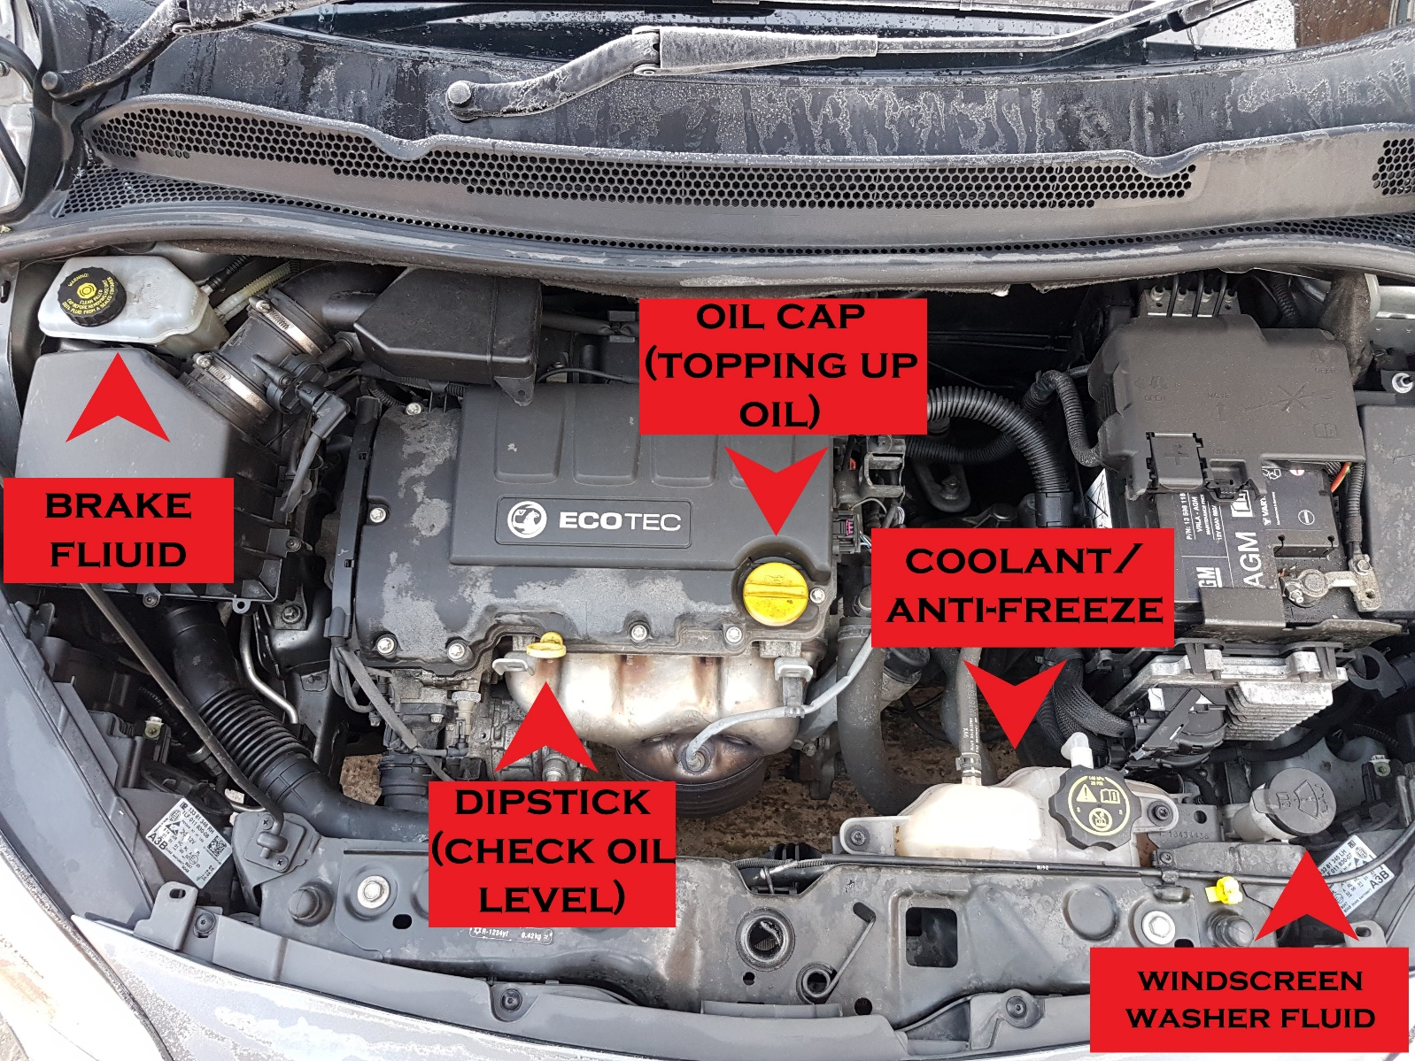

Heater controls
